**Project: dohMPI, EDEN and EpiTrax**

**Background:** Utah’s integrated surveillance system **EpiTrax** (formerly known as **TriSano**) is working to improve data quality and person linkage within its system. Improving person linkage will more accurately assign the correct event/case to a person and will increase its capability to link to other Utah Department of Health systems. Linking the disease surveillance system to other datasets is extremely important to epidemiologists who conduct case investigations because they will be able to have a more comprehensive view of the interested person(s), such related diagnosis conditions that are not captured by traditional diseases surveillance data sources. In addition, from the research perspective, the more data included the better, both in terms of the number of cases and the details and the extent of the health information. One data source that is frequently requested to be linked to EpiTrax is the Electronic Death Entry Network (EDEN)—Utah’s death registration system. This database, among other things, records the underlying cause of death, any antecedent causes, co-morbid conditions and other significant contributing conditions. Incorporating this information into EpiTrax would have many useful use cases such as improving quality of case investigations and case management among epidemiologists by not taking time and resources to contact deceased individuals.

**Proposed Method**: The Utah Department of Health has a tool, Department of Health Master Person Index (dohMPI), which can be used to identify a patient within or across participating systems. It uses a number of patient attributes including name, birthdate, and gender to identify matches. doHMPI contains only identifiers and source system identification numbers; it does not contain any program-specific information. Recently, through a series of manual reviews and algorithm adjustments the quality of the dohMPI system was measured, recorded, and improved until suitable for production. Using dohMPI to link death records with Medicaid Eligibility claims file resulted in a **precision of 99.43%, recall of 88.75%, and F-Measure of 0.94**. **Therefore, dohMPI will be able to facilitate and provide identification services to de-duplicate people with EpiTrax and link identification between the EpiTrax and EDEN. The diagram below (Figure 1) illustrates the role of the dohMPI in the overall UDOH enterprise.**

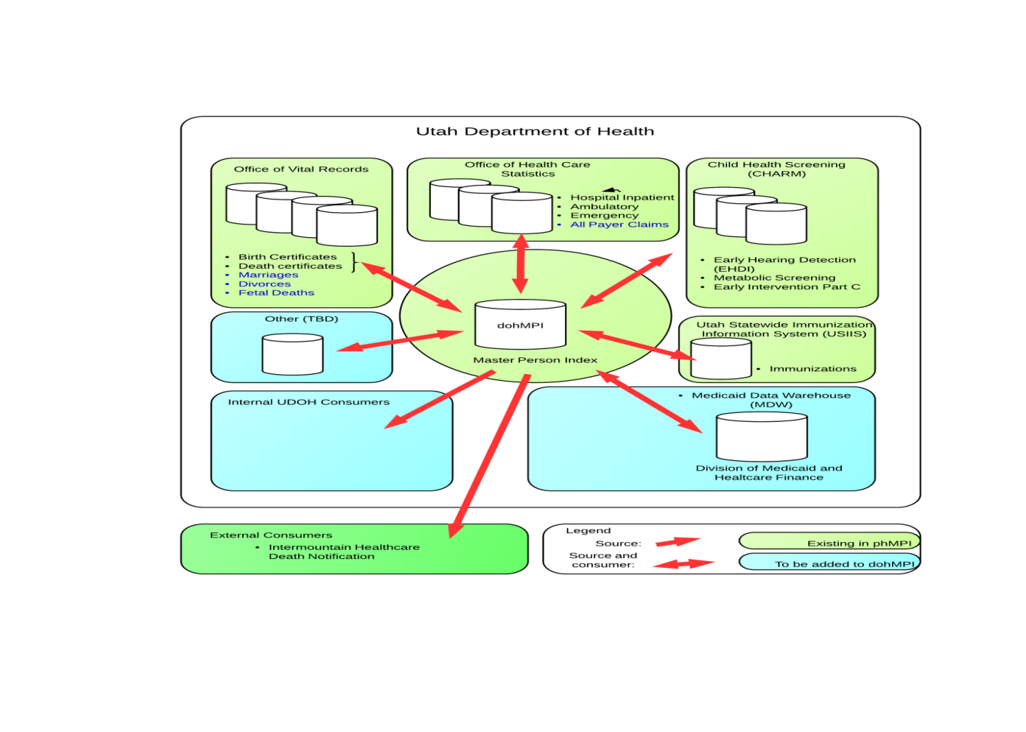

Figure : dohMPI Overview

In order to extend dohMPI for use by EpiTrax a web API will need to be developed that can support a real-time quick matcher to provide deterministic matching. If a match is found, the service will return the MPI ID, the “golden data”, and EDEN ID (Statefile number) to EpiTrax. If a deterministic match cannot be performed the person information will be sent to a database (“ToBematched”) that will be routinely monitored by dohMPI for an enhanced probabilistic match to be run; **however, since the project is focusing on the API component, this step is out of scope for the project**. One the information is returned to EpiTrax, the disease surveillance system will then query EDEN using the StateFile Number. If a EDEN match is found it will return the following: 1) underlying cause of death; 2) contributing causes of death; and 3) manner of death.

**Conclusion:** Using dohMPI will enable events and diseases in EpiTrax to the linked a unique person. In addition, because EDEN is already a data source in dohMPI, it will assist in assist in the query and retrieval of all relevant data to death information that can be used by the EpiTrax users to make informed decisions.

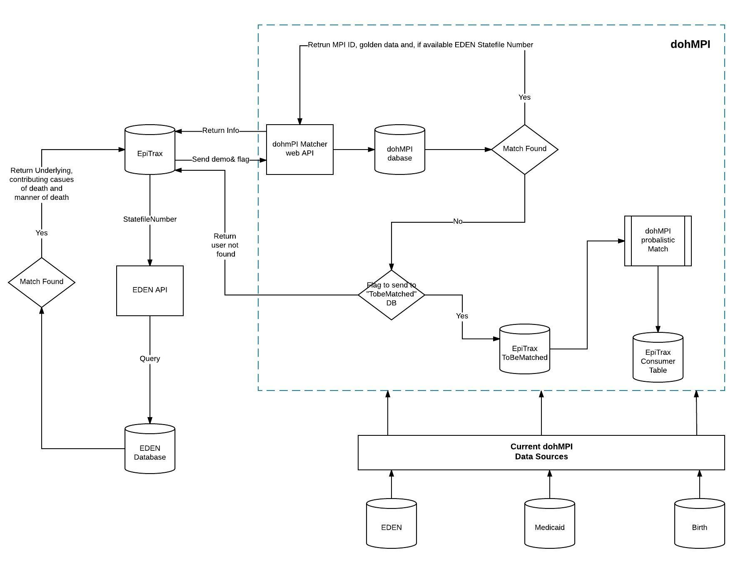

Figure 2: Project Flow

**What is EpiTrax?**

EpiTrax is Utah’s integrated surveillance system. Historically, communicable disease surveillance data was held in a number of different stand-alone databases, that were managed and funded independently. These databases were developed by CDC, and primarily used to transmitted surveillance data from the state health department to CDC. Local health departments did not have access to these databases, although they were responsible for collecting the data that would population them. In 2009, Utah implemented a new, home-grown, integrated surveillance system, UT-NEDSS (now EpiTrax), that would hold surveillance data previously managed by these disparate systems. In addition to consolidating all communicable disease data into one database, EpiTrax also expanded access to the local health departments. The figure below shows the biggest databases EpiTrax holds:

* NETSS collected data on approximately 70 different communicable diseases
* TIMS, held tuberculosis case management and investigation data
* STD MIS contained information on chlamydia, gonorrhea, and syphilis
* ArboNet, captured data on diseases transmitted by mosquitoes
* eHARS, managed data on persons living with HIV
* Blood lead: collect and store blood lead testing results for the Environmental Epidemiology Program
* Healthcare-Associated Infections (HAI) data

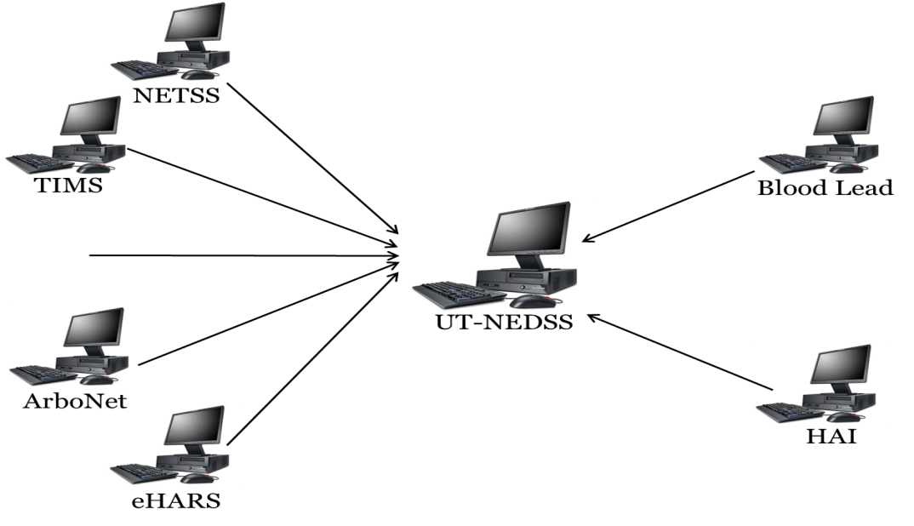

Figure : EpiTrax-Utah's Integrated Surveillance System

**EpiTrax Relevant Technical Overview:** It's a java app running in Wildfly using PostgreSQL database server.

**What is EDEN?**

EDEN is an electronic death registration system that allows user to register death certificates electronically. Death certificates are important legal documents that establish the date, cause, and other characteristics of death for legal and public health purposes. Key users include funeral directors, physicians, local and state health department officials who each have a role in the registration of a death certificate.

EDEN Relevant Technical Overview: EDEN is a web-based program that uses a Oracle database. However, for this project PostgreSQL can be used.

**What is dohMPI?**

An overview of dohMPI was given in the “Proposed Method” section. In addition to that information, dohMPI uses a PostgreSQL.

**Other Information:**

1. DDL for the database is available upon request